|  |  |  |  |
| --- | --- | --- | --- |
|  | 420-623 Windows Networking |  | Worth 4% |
| Winter 2017 |  |  |

Assignment #2b: Configuring Local Storage

|  |  |
| --- | --- |
| Part #1 | Initializing Disks |
| Part #2 | Creating Simple Volumes |
| Part #3 | Creating a Storage Pool |
| Powershell | Removing Storage Components |

### Working with the Submission Worksheets

Each part of this lab requires that you answer questions, create screen shots, and perform other activities that you will document in a worksheet named for the lab. As you perform the exercises in each part, open the appropriate worksheet, fill in the required information, and save the file to your drive.

### After completing this assignment, you will be able to:

* Initialize new disks
* Create storage spaces, disks, and volumes with Server Manager
* Create volumes with the Disk Management snap-in

## Part #1: Initializing Disks

|  |  |
| --- | --- |
| Overview | In this exercise, you use two different tools to bring three new disks online and initialize them in preparation for creating storage volumes. |
| Mindset | Adding disk drives is a common server hardware upgrade, requiring an administrator to prepare them for use. |

1. In Server Manager, click File and Storage Services. A File and Storage Services submenu appears

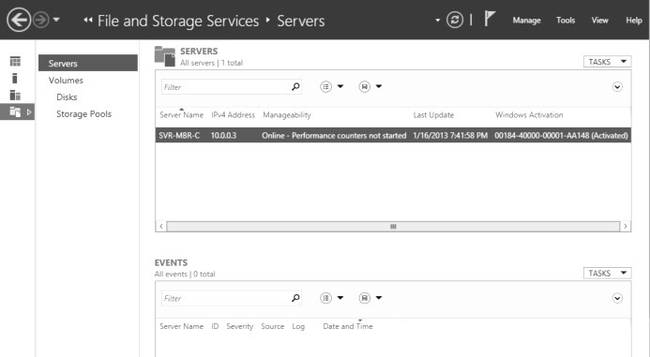

The File and Storage Services submenu in Server Manager

1. Click Disks. The Disks page appears, showing one online disk and four offline disks.

|  |  |
| --- | --- |
| **Question #1** | *The offline disks you are given are on the SAS bus – why?*  Because that’s the interface they use. |

1. Bring disk 1 online and initialize it.

|  |  |
| --- | --- |
| **Question #2** | *Disk 1 gets initialized as a GPT disk? What is that?*  *Guid partition table, file system* |

1. In Server Manager, click Tools > Computer Management -> Disk Management.

1. From disk management, bring disk 2 on-line and initialize it.

|  |  |
| --- | --- |
| **Question #2** | *You have the option of initializing the disk as MBR? What is that?*  *Main boot record, file system* |

1. Repeat the previous steps to initialize disk 3 and 4.

|  |  |
| --- | --- |
| **Question**  **#4** | *How does the Disk Management snap-in differ from Server Manager in regards to initializing disks?*  ***It shows the partitions aswell*** |

## Part #2: Creating Simple Volumes

|  |  |
| --- | --- |
| Overview | In this exercise, you use two methods to create simple volumes, using Server Manager and the Disk Management snap-in. |
| Mindset | Server Manager and Disk Management both provide wizards for creating simple volumes, with similar capabilities. |

1. On your VM, in Server Manager, in the File and Storage Services submenu, click Volumes. The Volumes home page appears.
2. In the Disk tile, open the New Volume wizard.
3. Create a new 5GB NTFS volume.

|  |  |
| --- | --- |
| **Question**  **#5** | *What is a volume in this context? What is NTFS? What did the other options mean? Be specific.* |

1. Open the Computer Management console. The new volume you just created should appear in the Disk 1 pane of the Disk Management snap-in.
2. Create a simple volume on disk 2 from the disk management snap-in. Use all the available space along with NTFS.
3. Once the wizard creates the volume, it should appear in the Disk 2 pane.

|  |  |
| --- | --- |
| **Question**  **#6** | *What is the PowerShell syntax for creating a simple volume of the same size on disk 3 using the drive letter G?* |

1. Create a simple volume on disk 3 with the drive letter G: using Windows PowerShell, set the size to 5GB.
2. Take a screen shot of the Disk Management snap-in, showing the three volumes you created, and then paste the resulting image into the worksheet as screenshot #1.

## Part 3: Creating a Storage Pool

|  |  |
| --- | --- |
| Overview | In this exercise, you will create a storage pool, which consists of space from multiple physical disks. |
| Mindset | Storage pools are a new feature in Windows Server 2012, which enable you to create a flexible storage subsystem with various types of fault tolerance. |

1. On your VM, in Server Manager, on the File and Storage Services submenu, click Disks. The Storage Pools home page appears. Right-click and select reset on disk #1, #2, #3 and #4.

**NOTE**: You may need to re-partition everything using Computer Management, if you run into problems in this section, talk to Jim

|  |  |
| --- | --- |
| **Question**  **#7** | *What does resetting a disk do?* |

1. Using the Storage Pools tile, create a new storage pool.
2. Name the disk pool “**Pool1”**
3. Add PhysicalDisk1 and PhysicalDisk2 to the pool.

|  |  |
| --- | --- |
| **Question**  **#8** | *What is a storage pool exactly? Why is the storage pool you created only 8.5GB?* |

1. Select **Pool1** in the Storage Pools tile.
2. Create a new virtual disk called **Data1.**
3. In the layout list, select Parity and click next. A warning appears, stating that the storage pool does not contain a sufficient number of physical disks to support the Parity layout.

|  |  |
| --- | --- |
| **Question**  **#9** | *Why is the parity layout not a valid option when there are only two physical disks in the storage pool?* |

|  |  |
| --- | --- |
| **Question**  **#10** | *Contrast parity and mirrored virtual disks.* |

1. Create a mirrored layout using fixed provisioning and the maximum size. **Deselect the *Create a volume when this wizard closes* option**.
2. Take a screen shot of the Storage Pools page, showing the storage pool and the virtual disk you created, and paste the resulting image into the worksheet as screenshot #2.
3. In the Virtual Disks tile, right-click the Data1 disk you just created and, from the context menu, create a New Volume.
4. Create a volume on Data1 using all of the available space, the NTFS file system, and the drive letter J.

|  |  |
| --- | --- |
| **Question**  **#11** | *At this point in the lab, what would happen to any data stored on the E:, F:, G:, and J: drives if* ***Disk 2*** *on the server was to fail?* |

## Powershell: Remove Storage Components

|  |  |
| --- | --- |
| Overview | In addition to the graphical tools provided with Windows Server 2012, you can also manipulate the storage subsystem using Windows PowerShell commands |

To complete this part, list the Windows PowerShell commands needed to delete all of the storage components you created up to now in this assignment. Then, restartthe server and take a screen shot of the Storage Pools page showing the removal of the storage pool and the virtual disk you created. Paste the resulting image into the worksheet as screenshot #3.

## Submission

Your assignment worksheet should have 3 screen shots and 11 answered questions.

Please use the Excel spreadsheet from Lea as the basis of your document. Screenshots should not exceed 3/4 of the height of the screen and should be stored in column “B”. Rows should be resized so that labels align properly (i.e. screenshot #2 in A2 aligns with the screenshot in B2).